JavaScript eventListener Method

The EventTarget interface provides multiple methods for handling the events in javascript on DOM objects.

addEventListener() :
It is very easy to add an event to any object in javascript using addEventListener(). We can even add multiple event listeners to a single object of the same type. These events will not override each other and will execute properly as expected without affecting each other’s working.
Events Added In the Code for addEventListener():
click : Button color changed to LightBlue and the message displayed as “Button was clicked!”
Mouseover: Button color changed to Green and the message displayed as “Mouse over button Action!"
mouseenter: Button color changed to Green and the message displayed as “Mouse Enter Event on the button!"
mouseleave: Button color changed to Green and the message displayed as “Mouse left from the button!"
keydown(Enter): Button color changed to Red and the message displayed as “Enter key pressed!”.

----------------------------------------------------------------------------------------------------------------------------------

removeEventListener() :
The removeEventListener() method removes event handlers that have been attached with the addEventListener() method:

Events Added In the Code for removeEventListener():

Click: Onclick of the button, increase the click count and display the message with click count. Once it reaches 3, the click event removed and display the message as “You clicked the button 3 times. Event listener removed! Double Click to Enable the Button”
dbclick: once doubleClick the button, the button color changed to Green and the message displayed as “Button Enabled. Presse Enter key to start again”
keydown: (Enter): Button color changed to lightcoral and the message displayed as “Enter key pressed! Refresh Page to Start Again”.
Code: (HTML, CSS-Internal and JS – Internal)
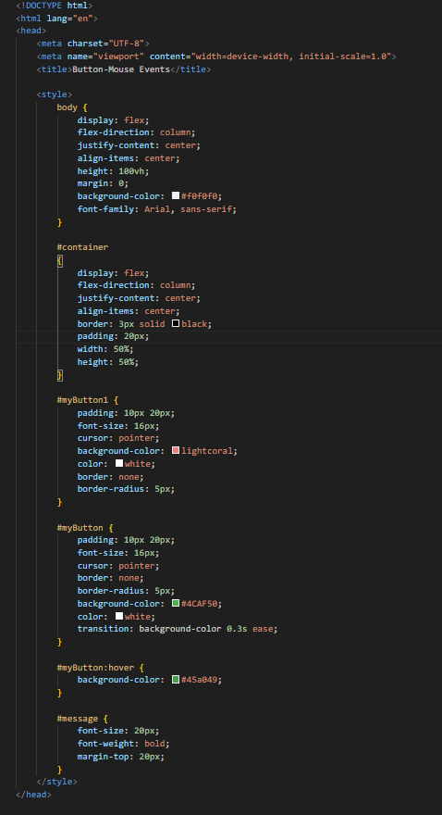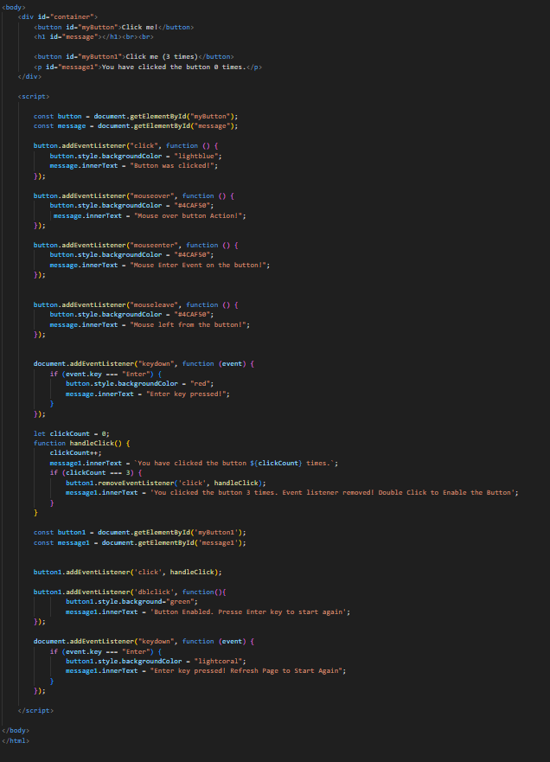
click,mouseenter,mouseleave,keydown events Output:
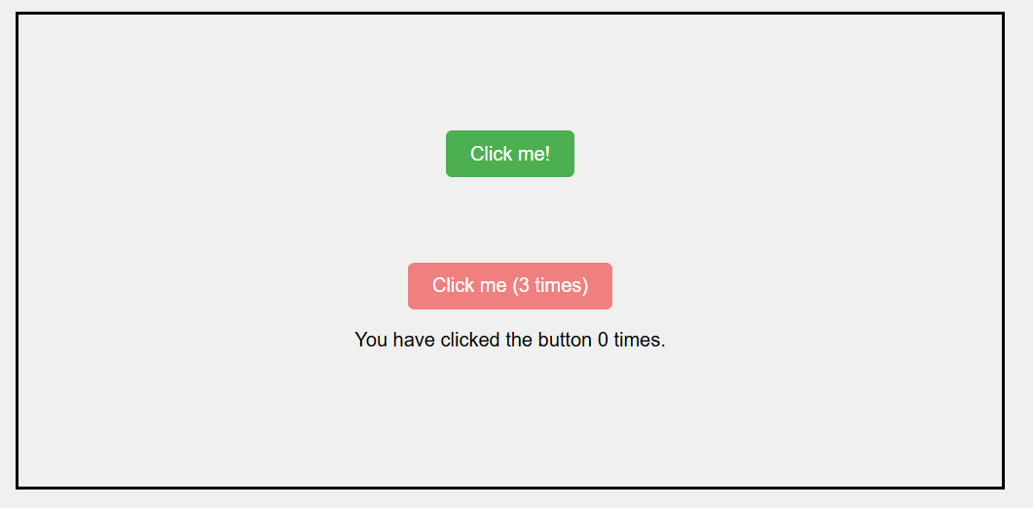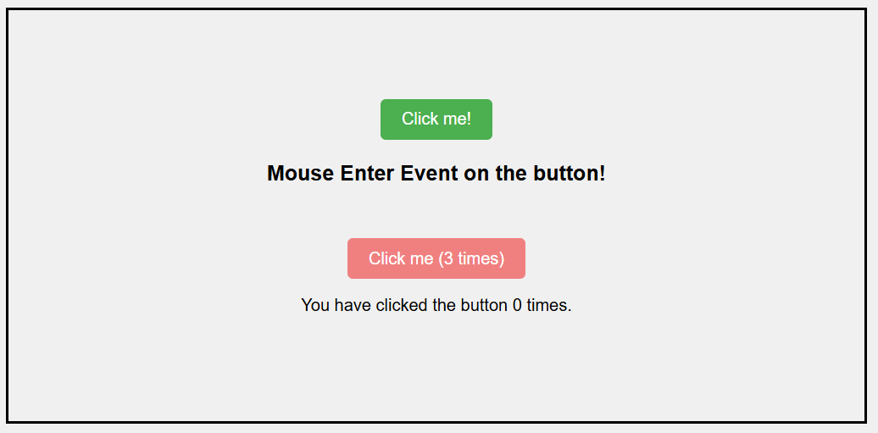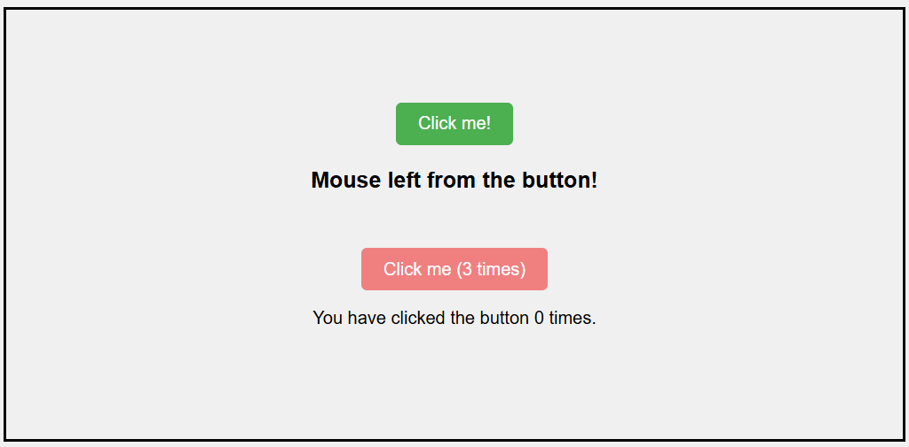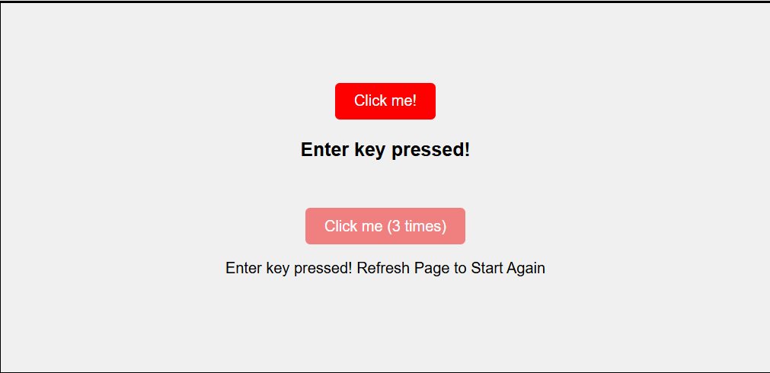

click,dbclick,keydown and removeevent(click) Output:
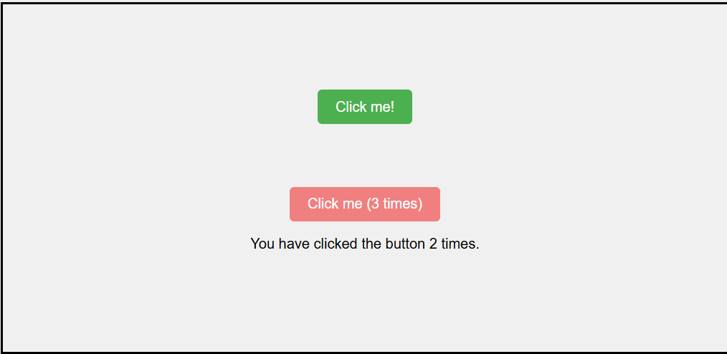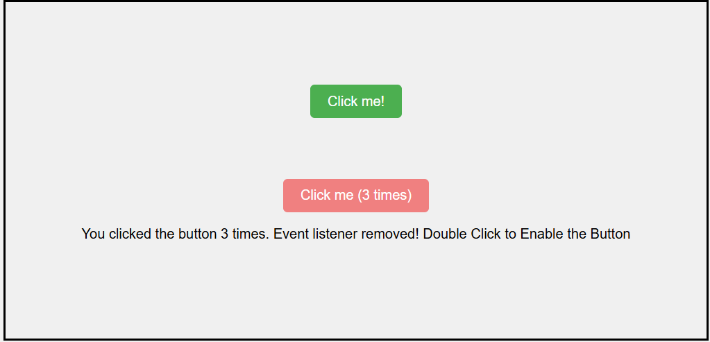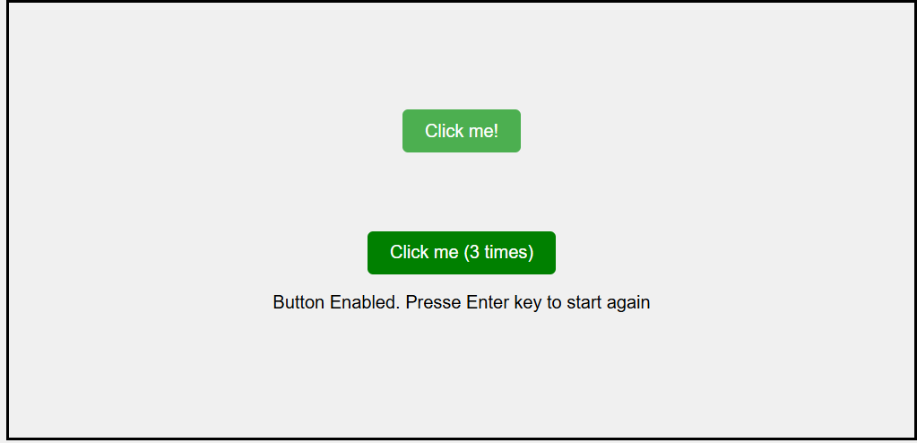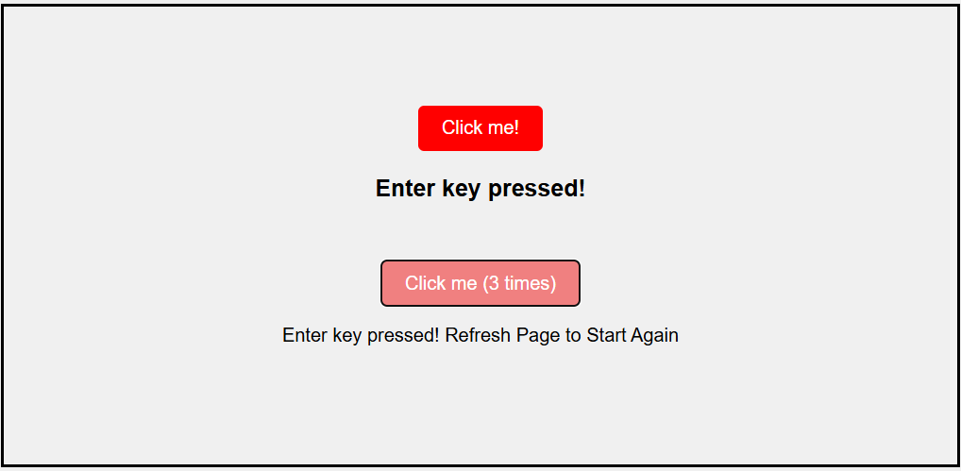

resize, scroll and keydown events:
resize: resize of the screen display the message as “Window resized! New dimensions: width and height of the screen”
scroll: scroll the screen shows the message as “You have scrolled! Scroll position: scroll range”
keydown(Enter): press Enter key display the message “You pressed the Enter key!” in Green color
keydown(Escape): press Enter key display the message “You pressed the Escape key!” in red color
keydown(anykeys other than Enter and Escape): Press any key other than Enter and Escaope the medssage will be displayed as “ You pressed the “PressedKey” key! in black color.
Code: (HTML, CSS-Internal and JS – Internal)
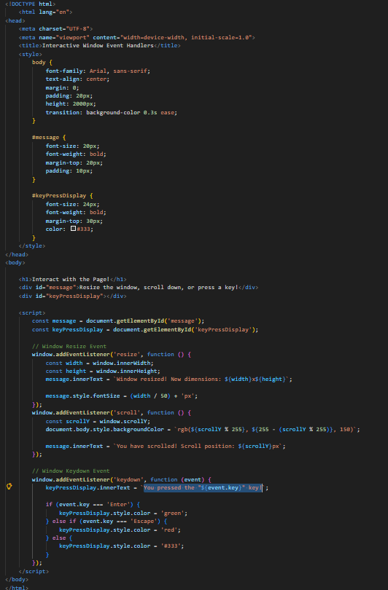
resize and scroll event Output:
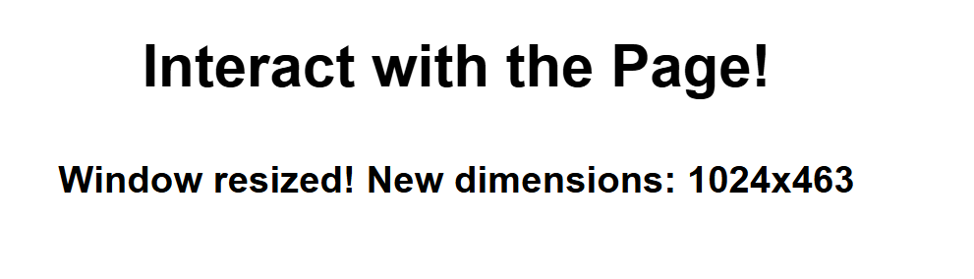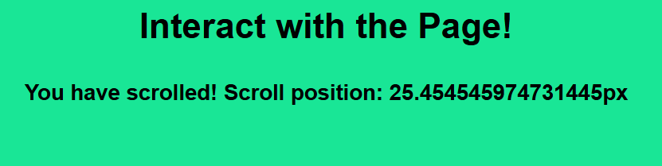
Keypress event Output:
